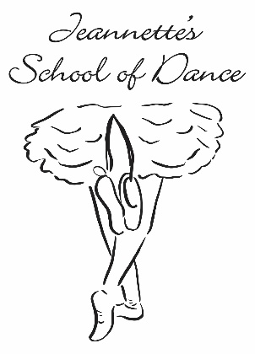
Looking for something new to do for your child’s next Birthday?

Let us celebrate their next birthday with a party at Jeannette’s School of Dance! Our customizable parties are 2 hours in length and include dancing, games, party bags, tableware, decorations and face painting! Just give us their theme and we will customize your child’s party from color choices, to music, to dance genre and decorations! All parents are expected to do is provide invitations, birthday cake, and any snacks or drinks. To secure the date and time of your party, Jeannette’s School of Dance will require a $75.00 deposit at the time of the booking.
Our memorable dance parties are an excellent way to celebrate your child’s birthday! For more information or availability, visit our website @ www.jeannettesdanceschool.com or call 215-487-0787.
2 Hour Party Includes:
1 hour of Instructed Dance & Games
1/2 Hour of Cake & Presents
1/2 hour of Face Painting & More Dance & Games
Tableware
Themed Decorations
Party Bags
Set-Up and Clean Up
Parents Provide:
Birthday Cake, Candles, Drinks & Food. The facility will be available 20 minutes prior to start time.

RESERVE YOUR CHILD’S PARTY NOW!

